Sarah Martin

C00257967

Lab 6

# Traffic Shifting

## Apply weight-based routing

I ran this command to route all traffic to the V1 version and then I opened up the Bookinfo site in my browser. I then

I ran this command to route all traffic to the V1 version:



then I opened up the Bookinfo site in my browser and noted there was no ratings.

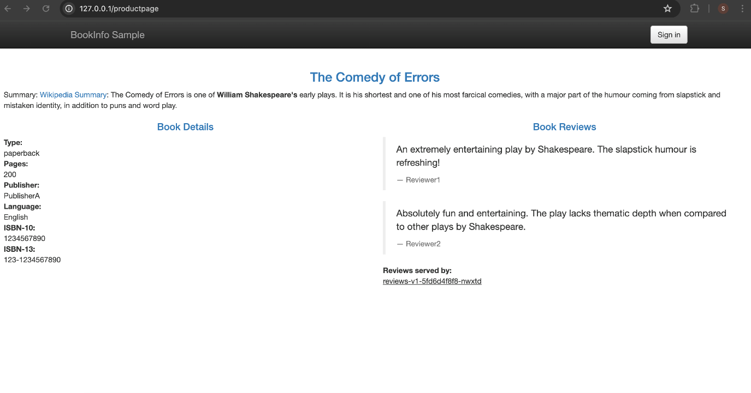

I transferred 50% of the traffic from reviews:v1 to reviews:v3 with the following command. I then waited a few seconds for the new rules to propagate and then confirmed the rule was replaced.

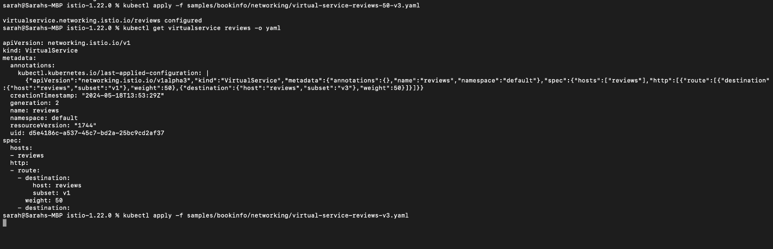

I then refreshed the product page to observe red coloured star ratings approximately 50% of the time.

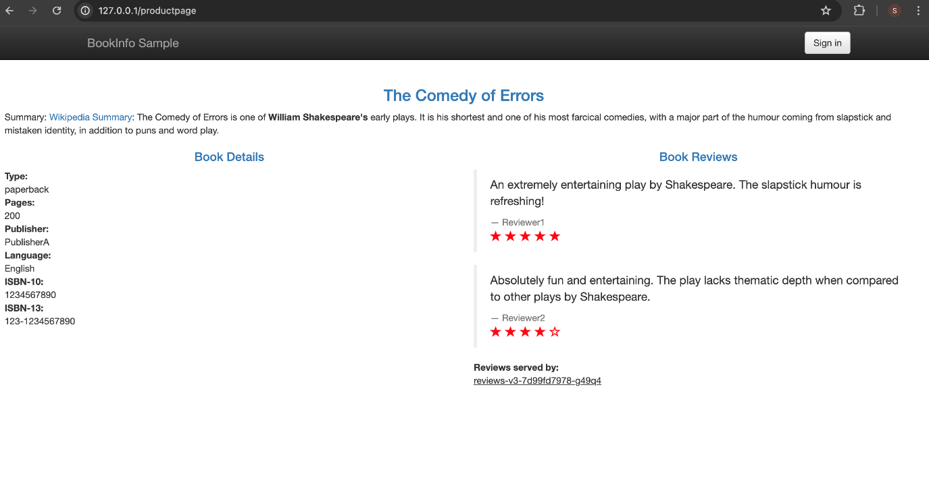

# Request Routing

## Route to version 1

I ran the following command to create the route rules:



I displayed the defined routes with the following command:

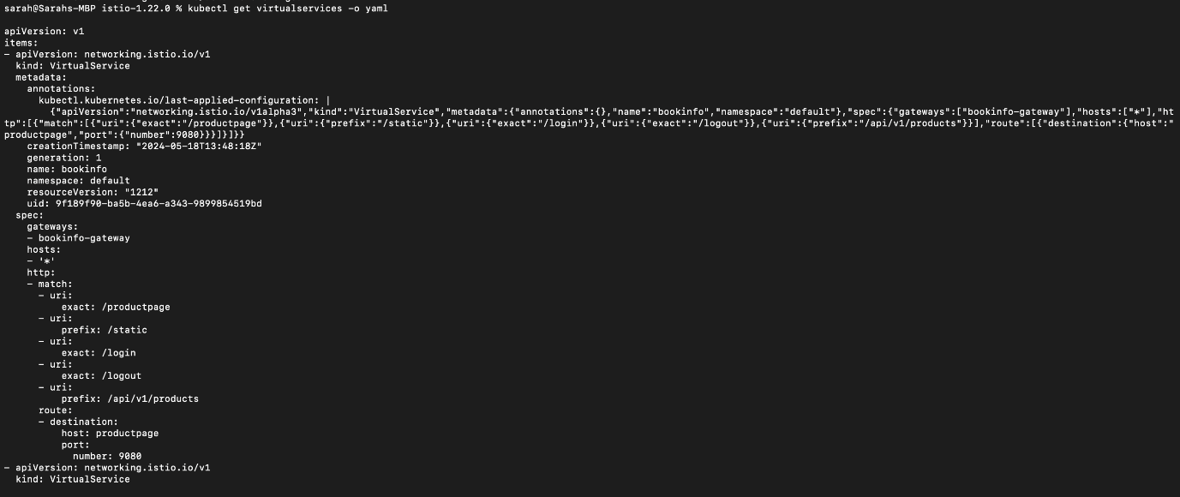

I ran the following command to enable user-based routing:



I confirmed the rule was created:

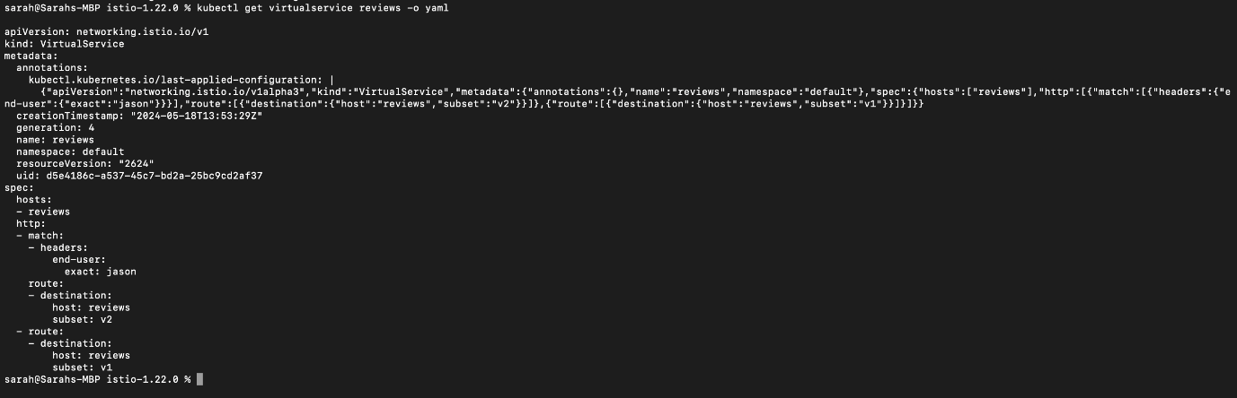

I logged in as the user jason on the product page and noticed that the star ratings appear next to each review:

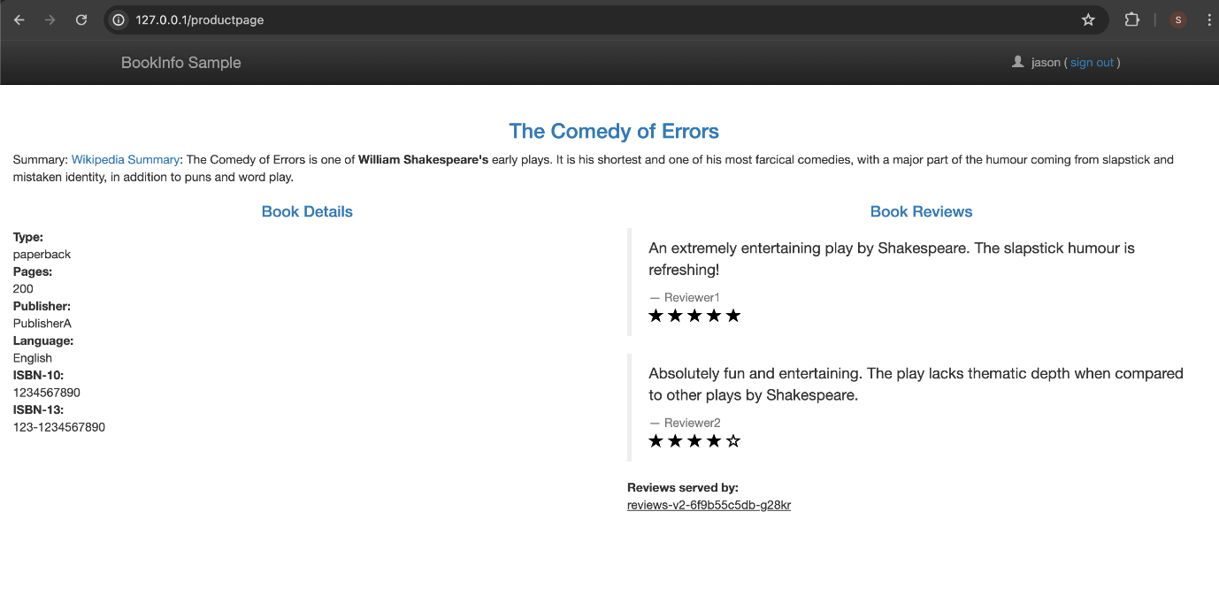

I then logged in as a different user and noticed that the star ratings were gone:

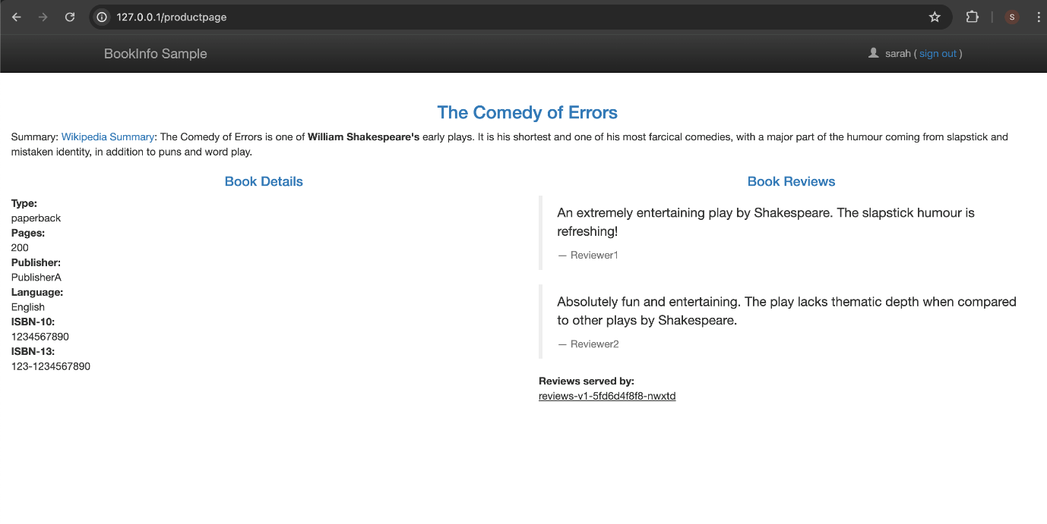

# Fault Injection

I created a fault injection rule to delay traffic coming from the test user jason



I confirmed the rule was created

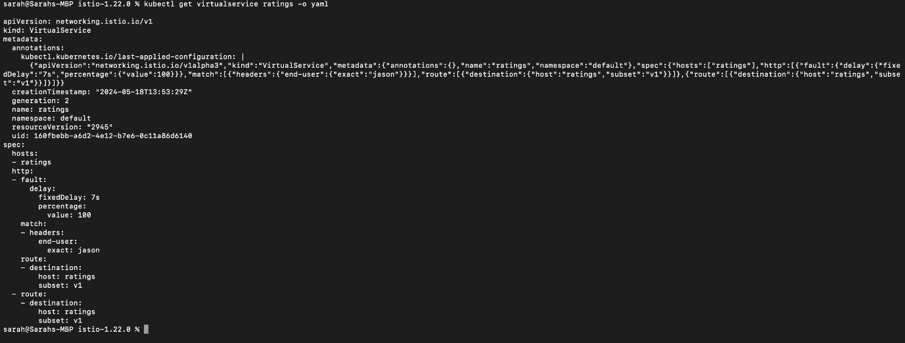

I opened the Bookinfo web application and logged in as the user jason. I expected the Bookinfo home page to load without errors in approximately 7 seconds. However, there is a problem: the Reviews section displays an error message:

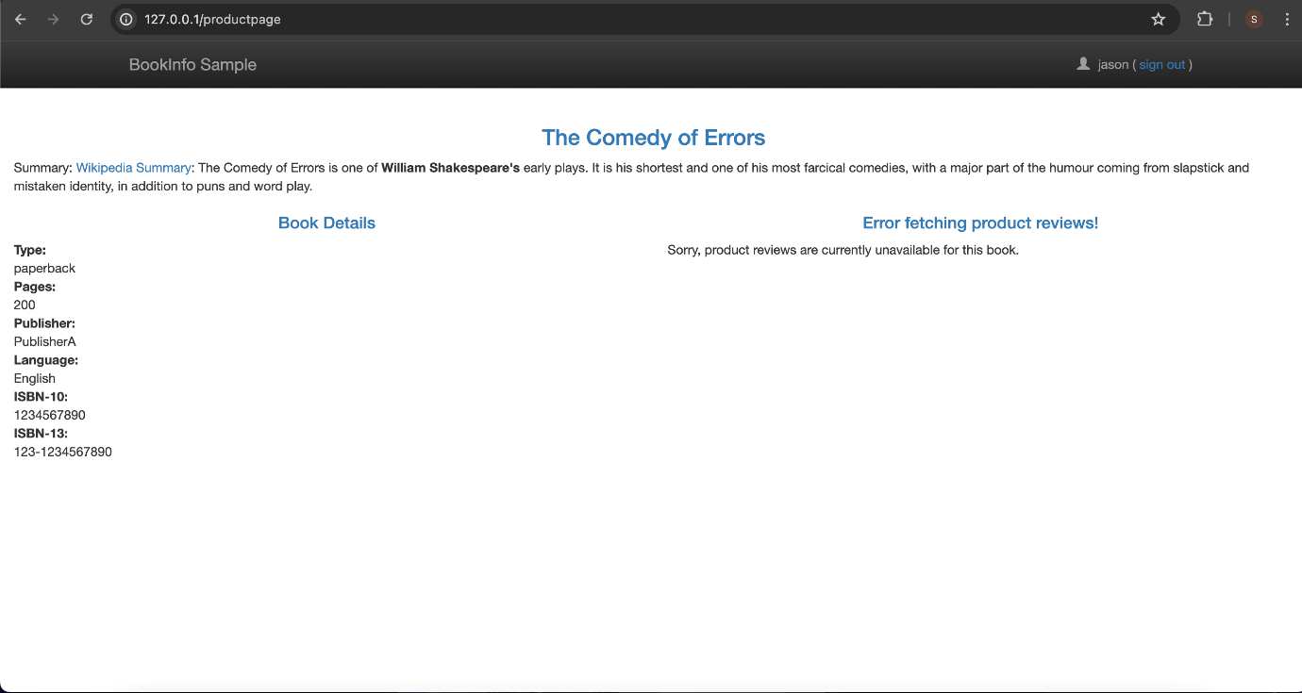

I created a fault injection rule to send an HTTP abort for user jason:



I then confirmed the rule was created:

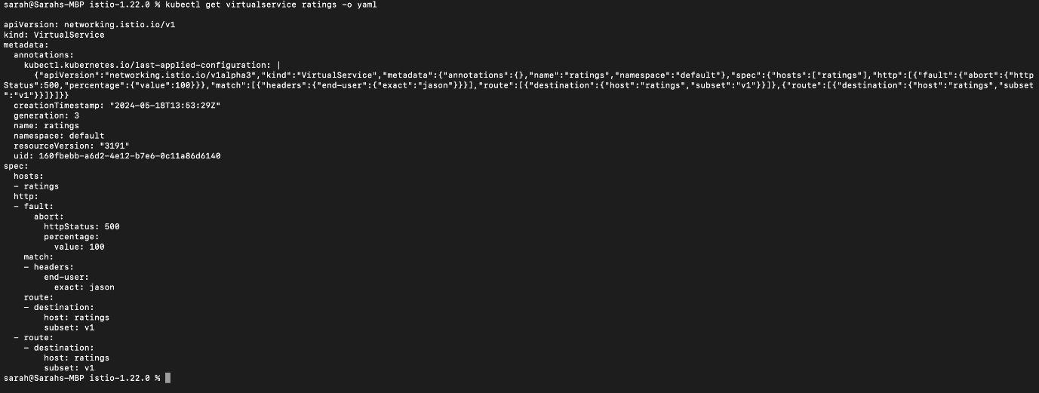

## Testing the abort configuration

I opened the Bookinfo web application and logged in as the user jason. The rating services is currently unavailable message appears:

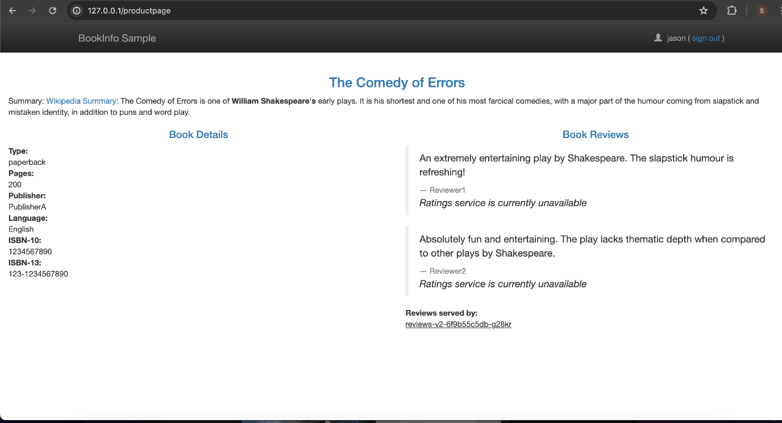

I then logged out as jason and noticed that /productpage still calls reviews:v1 for everybody but jason. I did not see any error message:

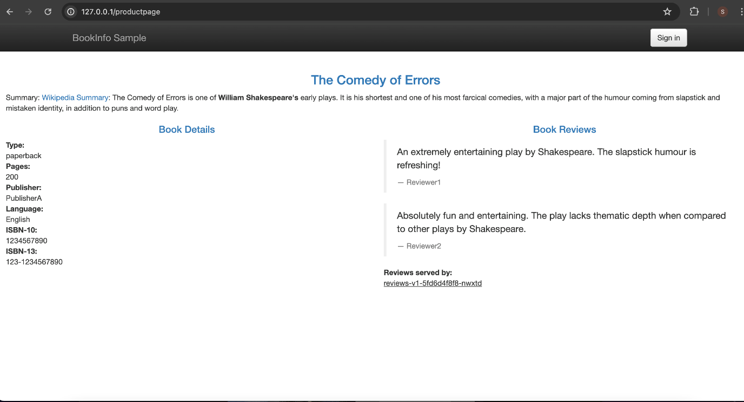

# Circuit Breaking

## Configuring the circuit break

I created a destination rule to apply circuit breaking settings when calling the httpbin service:

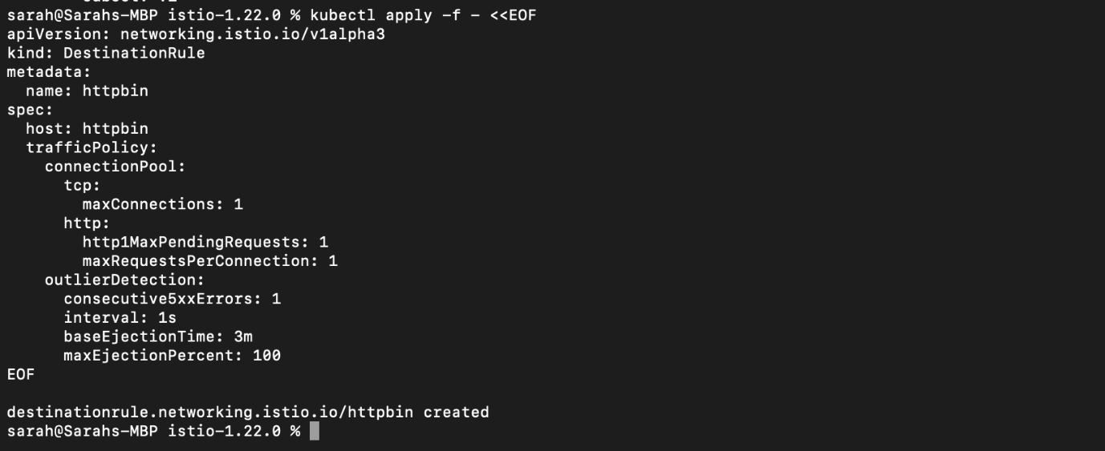

I verified the destination rule was created correctly: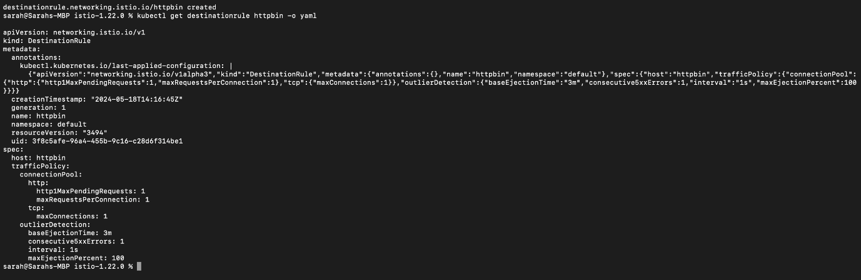

## Adding a client

I first manually injected the sidecar and then deployed the fortio application:



I logged into the client pod and used the fortio tool to call httpbin. I passed in curl to indicate that I want to make one call:

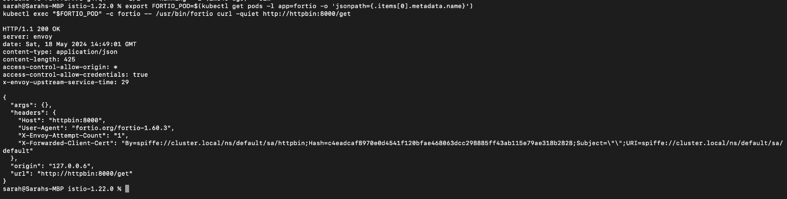

## Tripping the circuit breaker

I called the service with two concurrent connections (-c 2) and send 20 requests (-n 20):

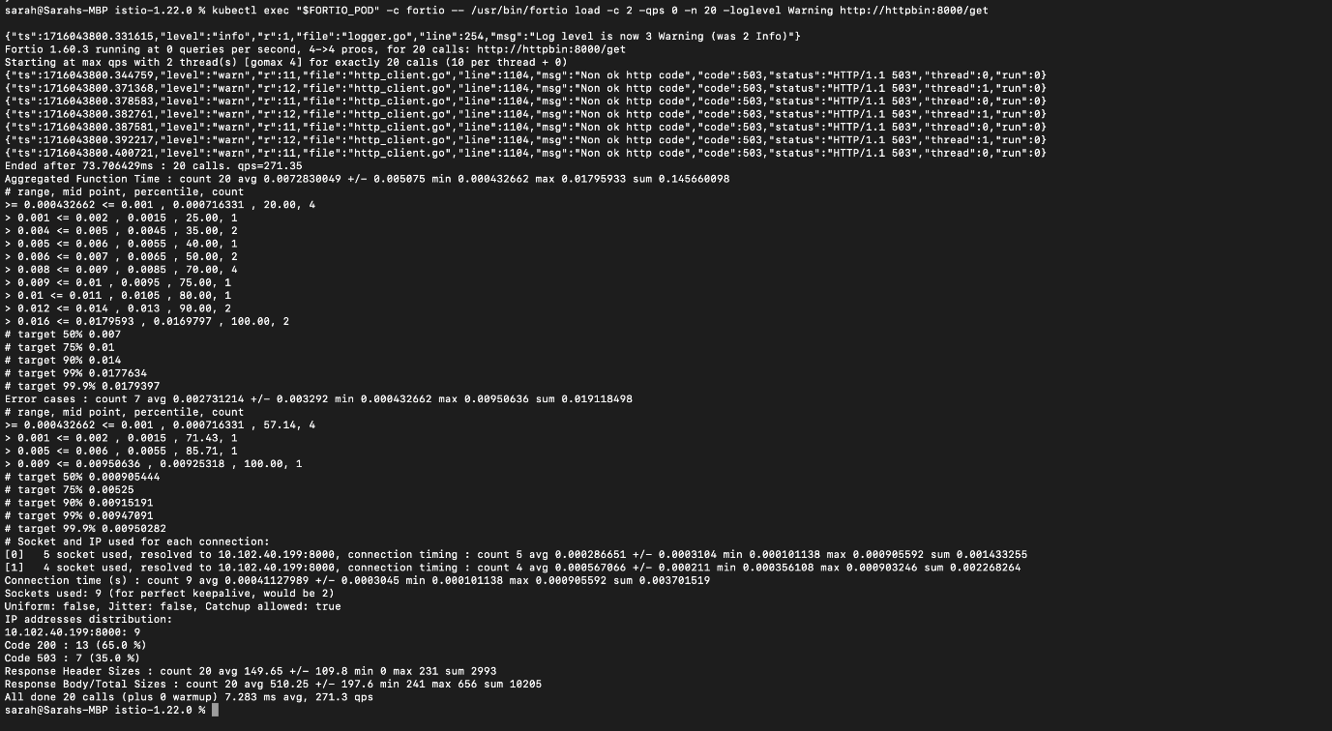

I then brought the number of concurrent connections up to 3:

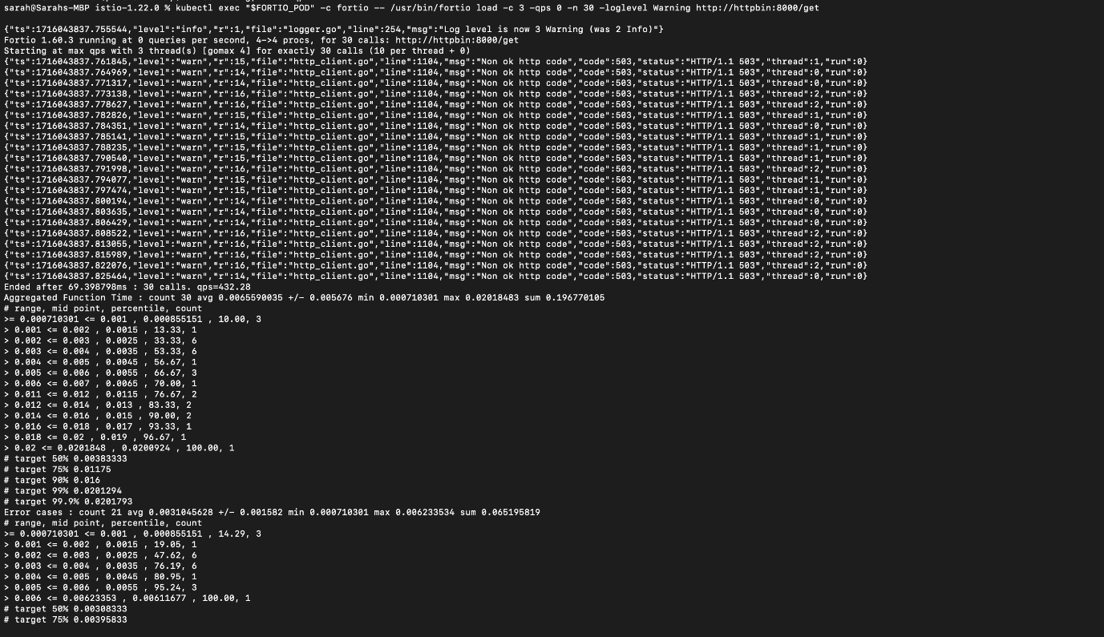

I queried the istio-proxy stats to see more:

